Renju lesson on November 1, 2001
Hello everyone! Welcome to Online Renju Class. We will now begin. Today we will continue the study of i8 opening. We are very close to the ending of i8 opening. We have two more 4th moves to check – g8 and i9. We will begin with g8.
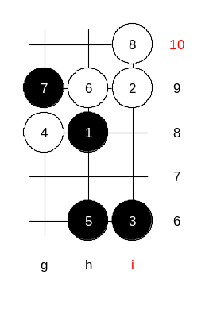
Do you know the 5th moves. Good. Most of you know. Which one is the easy sure win move? Indeed, 5-j7 wins fast. Move 5-j7 is so strong, we do not need to waste time to check this. Therefore, we will continue with the alternatives. Before we go to 5-g9, lets take a look at 5-h6. What does it tell you? Well, if we try to look a bit forward, we will notice something similar. Can anyone recognize it? Yes, it leads to d11 opening. So, we can call 5-h6 as a back-up move in case we are not sure about 5-g9. Right?

And now, lets see what is 5-g9 all about. I used to do a very deep analysis about this 5th move about 10 years ago.
There are two concepts about the 7th move. Bensonla and yyfcsd are right, the two ways are 7-j7 and 7-h10. Move 7-j7 has not been analysed very much. Move 7-h10 is the traditional move here, we will try this. The following moves are traditonal too.
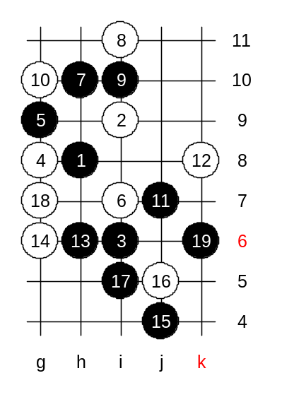
I remember, in 1990, I played in USSR Team Championship. In the first round, I met a Russian player Skuridin. We played this variant, I was black. At that time, I did not know the theory here. If I remember right, I played 13-f6 at that time. A space move. I played f6 with the plan that white goes h6 and I go g5. Then black would control the whole space. Do you know what is a “space move”? Space move is a move that is far away from other stones, however, it is linked to other stones and uses their support. That makes a space move powerful. Remember, space move without links to inner stones, without support, is a weak move.
At that time I played 13-f6. But one year later, I made an analysis about 13-h6 and proved sure win there. So, I will teach you about 13-h6. The idea of h6 is to make the h-line powerful. According to this concept, black does not hurry to make a space move. The idea is to wait a moment, and let white choose the defense direction, and after that go to the opposite space.
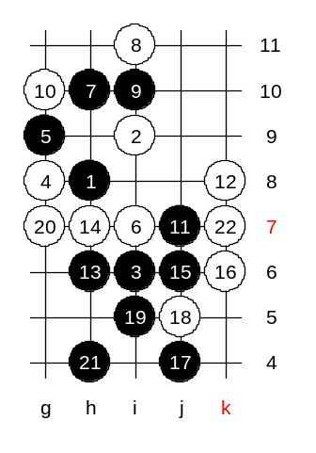
We choose g6 block. Now it is time to make the space move to opposite side. J4 – good! Black wins very fast. Shall we try to defend here? OK, we try j5.

We will check another 14th move now. H7. How to win here? I will introduce you my thinking. First, how about VCT? Can black win straight? You say no. Why not? Let’s test, what’s the problem with that direct attack.

Black attack failed. But, it tells us something. We must take a look at the reason of attack failure. White got counter attack and black did not have VCF. Right? Now, imagine if black had a stone that helped black to have VCF. Where could that stone be?

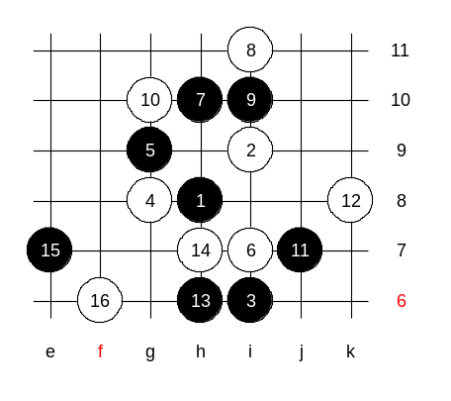
We go back to the 14th move and take another look. Tell me the good space move that would help the future VCF. Yes, 15-f7 !! Can you see how it helps the future VCF? Good! So, can white go f8 here? So, e7 created a powerful space line which white was unable to defend because of our attacking idea in lower side. So we must block at f6 or something, right? But then the powerful space line will do its work. How to win? I have an idea. We can leave it as homework. Ok?
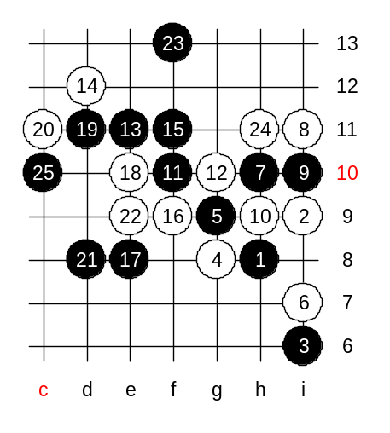

Another 10th move. 10-h9. I found sure win here as well. 15 moves on the board. It is a typical triangle. With sufficient space it always gives a black win. Can anyone suggest the defense plan for white? Ok, we test f9, as the majority suggested. As you see, black win is not difficult. I am sure there are more than just one way to win.

